Modeling Data in Excel

Mark Moufarrej
201402756
Section 8

Friday October 15, 2013
REPORT GRADING
Expected Features
1. Title Page: everything centered including title, name, date, etc. | /6
2. Typed Report using proper structure Introduction followed by Work Description followed by Conclusion followed by References | /6
3. Professionalism: spacing, 11- or 12-point font, grammar, spelling, punctuation, language, consistency, writing tips followed | /13
4. Introduction: motivation and objectives of work, overview, report organization | /8
5. Modeling process description (Work Description/Modeling Process) | /8
6. Cone equations (MathType) | /8
7. List of useful Excel tools (Work Description/Tools) | /8
8. Graphs - graph placed in a figure similar to Figure 1 (Work Description/ Results) | /8
9. Excel spreadsheet with graph and formulas (Work Description/Results) | /13
10. Discussion of results (Work Description/Results) | /8
11. Conclusion | /8
12. References – find and cite at least 3 references related to this assignment. | /6
TOTAL SCORE | /100
Introduction:

Motivation:
Microsoft Office provides the user with a very wide collection of programs, which come in very handy in our daily lives. Those tools enable us to accomplish various tasks in a very shorten period of time and with tremendous precision. Microsoft Excel is one of these tools qualified as a spreadsheet application, typically used to display and manipulate numerical data. Microsoft Excel provides data organization and analysis tools that enables to sort, extract and generate charts from spreadsheet data.

Objectives of work:
- Use Microsoft Excel’s capability to input formulas, to calculate the area and volume of a cone while given the radius and height of the base.
- Collect the data obtained into a representative graph.
- Use the functionalities of Microsoft MathType to type complex mathematical equations. The previous tool is usually provided with Microsoft Office another program for the Office collection.

Report Organization:
- Introduction (motivation, objectives of work, report organization)
- Work Description (Background, Cone Modeling Process, Tools, Results)
- Conclusion
- References

Work Description:

Background
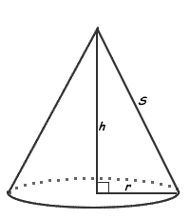
A cone is a pyramid with a circular base; in this case we will work on the right cone, which height perpendicular to its base. The area of the cone is and the area of the base is
Therefore the surface area of the cone is
The volume of the cone is
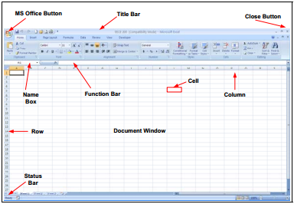
In this report we will see how the radius of the base affects the surface area and the volume of the cone using Microsoft Excel. In Excel input values are put into Cells that are sorted by Row and Column number (eg: A1). Also for each cell we can use the function bar which allows us to write more at ease and input formulas.

Cone Modeling Process:
We start by labeling our spreadsheet, we write in cell A1 the title of the project “NASA Cone Design problem’’, by pressing on the cell writing and just pressing enter (or by doing so in the function bar). We do the same for cell F1 and write the name and section number as it follows “Mark Moufarrej: (8)”.
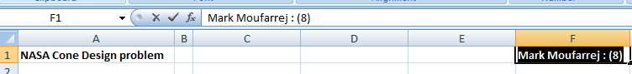

In this next step we should specify the design constants of the data entry, select cell A4 and write “Design”, then in A5 “Variables”. We then enter the actual variables with its units in cells A7 “Height (cm)” and A8 “Radius (cm)”. Also Excel reads increments: values than can later be added to other cells (or values). Therefore we will add in A9 “Radius Inc (cm)”. We should input the fixed values of these variables in row B respectively for each variable in B7 “20”, B8 “5” and B9 “2”. Note that sometimes the text entered in a cell if too long can overlap the cell of the next column (A and B), we can adjust it by going to “Home tab” then “Format/Autofit Column Width”
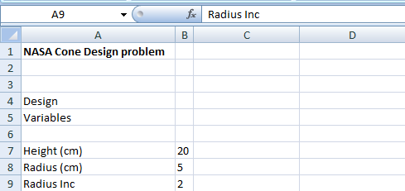

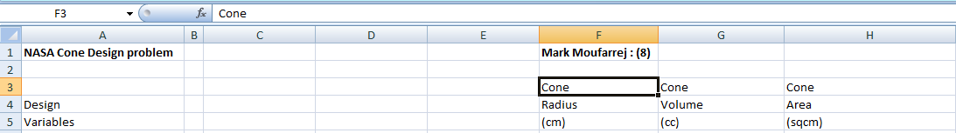
Now we should place the labels of the design variables with their units as we did with the constants.

Next we will have to input the formulas of each variable for Excel to calculate the volume and area according to the changing radius. The radius takes an initial value of 5 cm as written in cell B8, we thus write in cell F7 “=B8” to take the value of B8. Then the radius increases with an increment of 2 cm we then write in F8 “=F7 + increment”. The increment was set previously in B9. We then copy the same cell by sliding the arrow from F8 till F16.
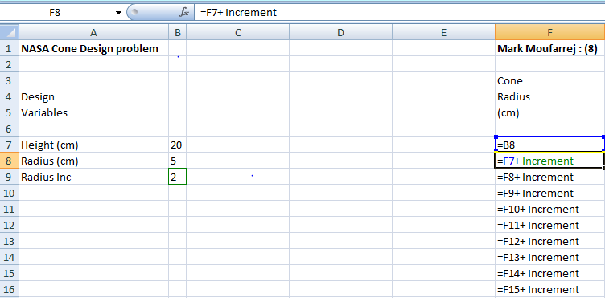

Now to let Microsoft Excel calculate each value we should input in the function bar the formula for each variable. For the volume of the cone we have , we should insert in cell G7 “=1/3*PI()*$B$7*F7^2” and drag cursor till cell G16 to get all required values. For the surface area of the cone we do the same and insert in cell H7 “=PI()*F7*($B$7^2+F7^2)^0.5”
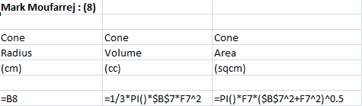

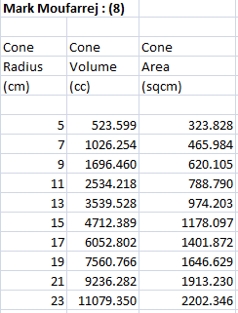
We should obtain such values:

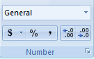
Also note that Excel allows you to choose how many decimals you want to see in the cells by going to home then numbers.
Finally to put all the results into a graph, the user should select the data that should be represented. Select values from cells F7 to H16 then go to “Insert”, “Charts” and select “Scatter with smooth lines and markers”.
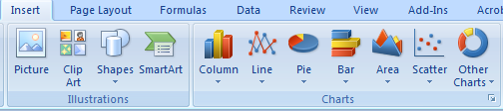
Excel also gives the option to manipulate the Legend of the graph but arranging units and position of the legend of each axis. To access the legend you should press on the chart then go to “Layout” then “Legend” under labels.
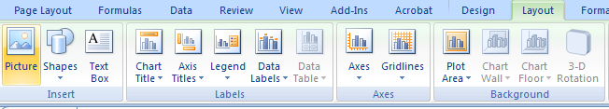
Excel Tools Summary:
- Adding the same specific value to other variables using an increment with the $ signed (e.g. =F7+$B$9)
- Transforming formulas and solving them on excel by writing them in a specific format (e.g. volume values =(1/3)*PI()*$B$7*F7^2 and the surface area values =PI()*F7*($B$7^2+F7^2)^0.5)
- Being able to apply same transformations on different cells by just writing them once and dragging the cursor which will apply the transformations respectively the linked cells
- Creating graphs with the Chart tool and being able to edit the legend.

Results:
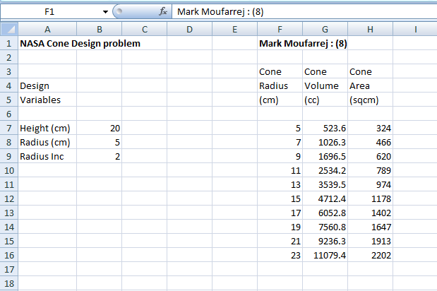

According to graph we see that as the radius of the base increases the volume and the surface area increases. They have a proportional relationship. We can also see that the volume and the surface area have different formulas, so they don’t increase at the same rate. The volume of the cone grows faster than the surface area. They are equal at radius r = 21cm (approx), then the surface area increases faster

Conclusion:
Through our work we could appreciate the flexibility of Microsoft Excel. That lets the user save a tremendous amount of time. We were able to calculate values according to complex equations that have easily been represented using MathType. Also the fact that Microsoft Excel allows us to represent results in a graph of our choice, allows us to notice the relationship between different mathematical formulas like the surface area and the volume of the cone.

References:
- Information Technology Department, Harvard Medical School http://it.hms.harvard.edu/pg.asp?pn=software_excel
- About Mathematics Online Source
http://math.about.com/od/formulas/ss/surfaceareavol_2.htm
- File given with the assignment by the department (obtained from Prof. Lina Karam at Arizona State University.

